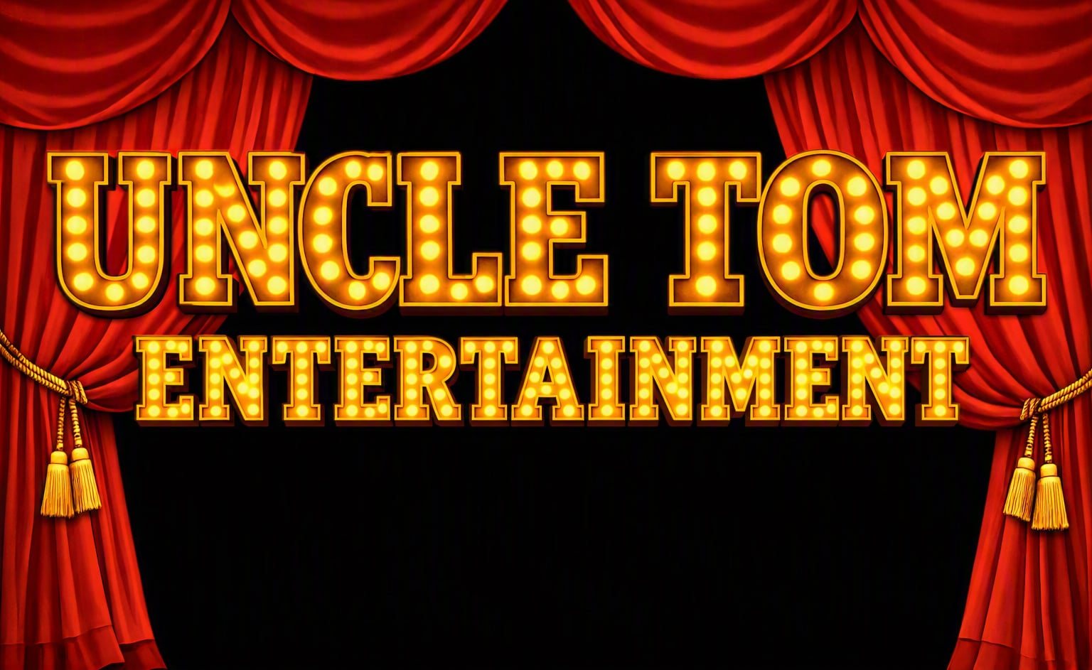

Uncle Tom Live
Show Partner Pack
Helping bring A Bloody Great Night to communities across WA (and the world)

Uncle Tom Entertainment was created with one simple goal: to bring people together for a bloody great night out.
We're more than just a comedy show. We're an entertainment company focused on creating memorable live experiences through comedy, audience interaction and community events.
Led by Tom "Uncle Tom" Leadbeatter, with Brad Hayden and media producer Zac, our team is passionate about delivering professional, engaging shows that leave audiences smiling long after they head home.
Whether we're performing in theatres, clubs, pubs or community venues, every show is built around one promise:
A Bloody Great Night Out.
As Uncle Tom Entertainment grows, so will the range of events, tours and productions we bring to audiences across Western Australia.
Who is Tom
Father of four, husband of 25 years, survivor of a broken neck, and proud husband of a wife who beat cancer. Uncle Tom Live was built from scratch to bring people together for a unique, interactive comedy experience

Who is Brad
Father of four, husband and a genuine funny man His quick wit and relaxed style are the perfect way to kick off a bloody great night.

Who is Zac
Zac – Production & Media

If you've seen a promo video or a great photo, chances are Zac was behind it.

He films, edits and captures the moments that keep the Uncle Tom Live story growing.

Why Partner With Uncle Tom?

Partnering with Uncle Tom Live gives your business exposure through our website, social media, live shows and promotional material while supporting local entertainment.

Our Audience

• Adults 30+
• Couples
• Corporate groups
• Community members
• Sporting clubs
• Theatre lovers
Uncle Tom Entertainment Partnership pack 2027

Bronze – $250
• Website listing
• 2 social posts
• 2 complimentary tickets

Silver – $500
• Everything in Bronze
• Logo on posters (where applicable)
• 4 tickets
• On-stage thank you

Gold – $1000
• Everything in Silver
• Premium logo placement
• 6 VIP tickets
• Banner/display opportunity

Tour Partner - $5000
• Everything in Gold
•10 VIP tickets to our Theare Shows
• Dinner for 10 at Lakers Taven on Don Russell Shows
• 5 Tickets to all local show
• Main placement on website and all social media
• Onsite promo filming from Uncle Tom and Brad

Why Support Uncle Tom Live?

Uncle Tom Live isn't just another comedy show. It's about bringing communities together for a bloody great night out while proving that no matter what life throws at you, laughter still wins.

Thank you for taking the time considering Partnering with Uncle Tom Entertainment
We’re just three blokes with a dream trying to build something special for Western Australia with your support that dream can become a reality.

We Genuinely hope you’ll join us this journey.

Tom, Brad and Zac

Website: www.uncletomlive.com.au
Email: info@uncletomlive.com.au
Phone: 0425 625 330

